Success continues in GCSEs at
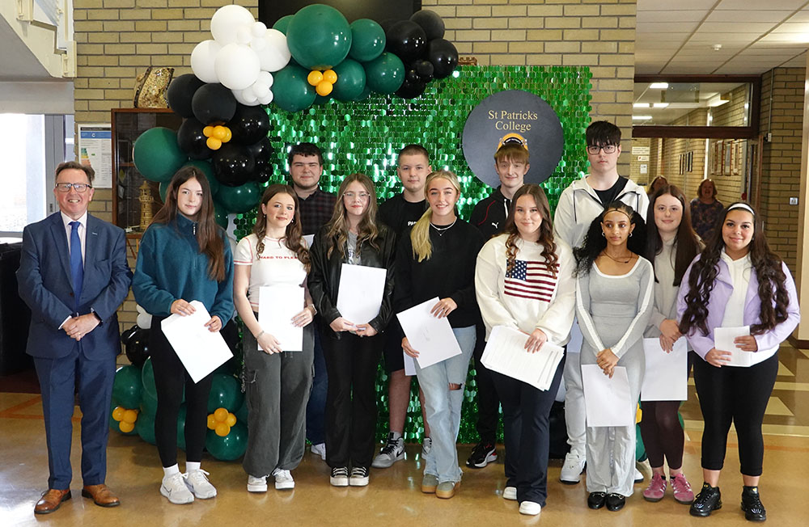
St Patrick’s College, Ballymena!

St Patrick’s College Year 12 students receive their GCSE results

Students in St Patrick’s College, Ballymena are once again celebrating excellent GCSE results this year.

One student has achieved a fantastic ELEVEN GCSE passes at A*-C. A further eight students have achieved TEN GCSE passes at A*-C, with a further nineteen students achieving between seven and nine GCSE passes, with a significant proportion of all these grades being top grades.

Eight subject areas – Occupational Studies (Design and Creativity, Technology, Engineering), OCN Religious Studies, OCN Science, Personal Success and Wellbeing, Polish, Prince’s Trust – are celebrating 100% performance at A*-C grades. 97% of English Literature, 94% of ICT, and 93% of Art & Design grades were achieved at A*-C, while a number of other subject areas have seen results at A*-C of 80 to 90%.

St Patrick’s Principal, Paul Fitzpatrick, congratulated all of the school’s Year 12 students on their hard work and success. ‘This has been another very demanding year for all of us in education, and these results are the culmination of a great deal of hard work on the parts of both students and teachers. I congratulate all of the students, as well as their teachers, who have worked hard to accurately reflect the ability, effort and success of the students. I would also like to thank the parents of the young people, for the encouragement and support they have provided to their children during the two years of their examinations. At an earlier stage in their education, these students were particularly affected by the pandemic, so it is very pleasing to have seen them make such good progress and fulfil their potential.

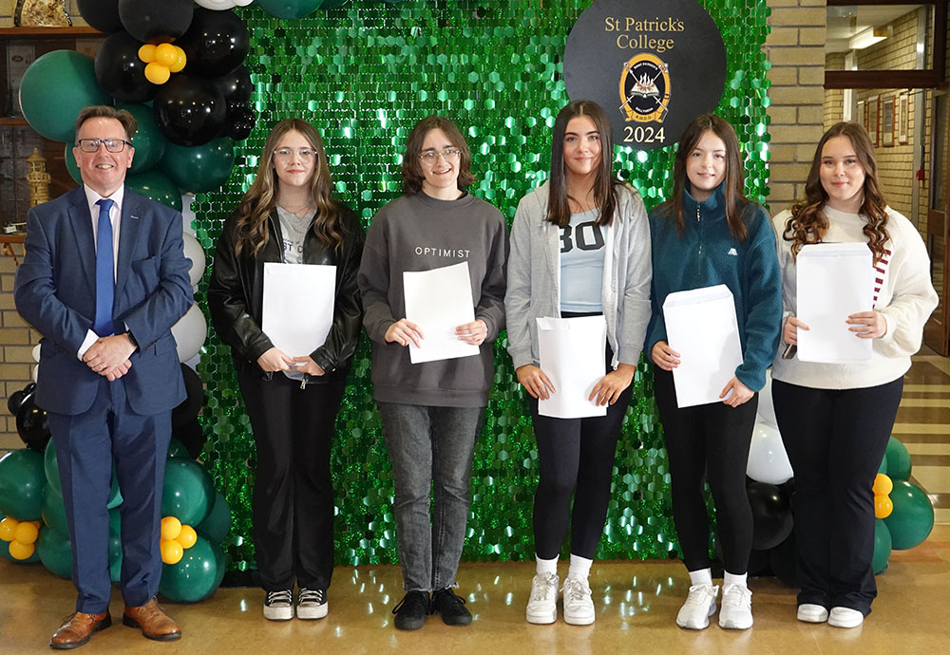

St Patrick’s College Principal Paul Fitzpatrick with some of the College’s highest achieving Year 12 students, who have each achieved a significant number of A* and A grades in their GCSEs

‘We are proud of the successes of all of our GCSE pupils, who between them in Year 12 have achieved an incredible 17 A* grades, 50 A’s, 134 B’s, 61 C* and 89 C grades. These are excellent results from students who, in many cases, had enrolled in St Patrick’s College five years ago with their confidence severely dented by the Transfer procedure.

‘I am sure their achievements will give our GCSE students the confidence and encouragement to go on to further success at A level.

‘I want to recognise the achievement of our students across all courses, including a number of applied courses delivered in school, and also the Occupational Studies courses delivered in the Northern Regional College. The outcomes from all of these courses have been excellent.

‘Overall, these results give us great confidence as a school as we continue to ensure that the students leaving St Patrick’s do so with the highest qualifications they can possibly achieve.

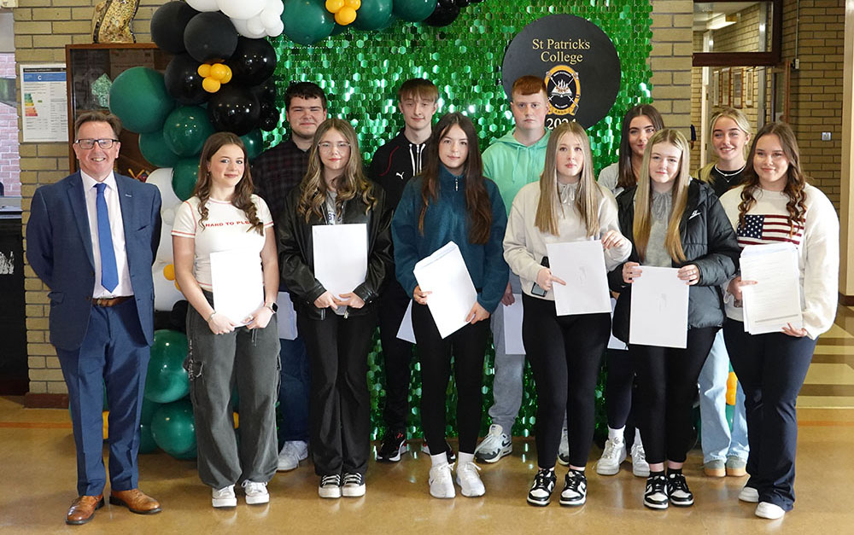

Mr Fitzpatrick with a number of the St Patrick’s College students who are celebrating the achievement of at least seven GCSE grades at A*-C

‘We made a decision a number of years ago to create a Grammar Stream at GCSE level, to give as many as possible of our students the greatest chance of success. Each year, two Form Classes take a programme of ten GCSEs, including Double Award Science and English Literature. We are very pleased that 64% of these students have achieved at least seven GCSE grades at A*-C, and also that 54% of these students have achieved at least five GCSEs at A*-C including English and Maths.’

Mr Fitzpatrick also praised other successes within the Year 12 group, particularly ten students who have completed the Prince’s Trust course, gaining a Level Two qualification equivalent to two GCSEs at Grade B. 20 students have successfully completed the OCN Religious Studies course, equivalent to GCSE Grade B, while seven have achieved the same grade in OCN Science. In addition, 18 Level 2 qualifications have been achieved in Occupational Studies, equivalent to GCSEs at A*-C.

‘As a non-selective school, we celebrate success at all levels across the full range of ability. These are vocational courses, many of which our students access through the Northern Regional College, and they aim to broaden the educational experience of the young people, with a view to preparing them for further training or apprenticeships. I am delighted that these students have successfully embraced this opportunity, and I would like to thank the staff of the Northern Regional College for the partnership we enjoy, which is obviously benefiting our students.’

Results for last year’s Year 11 students in the GCSE modules they took this Summer are also excellent, and are a very encouraging indicator of continuing success for next year’s GCSE results. Mr Fitzpatrick congratulated these students on how well they have coped with the transition to Key Stage Four and wished them well as they progress to Year 12.

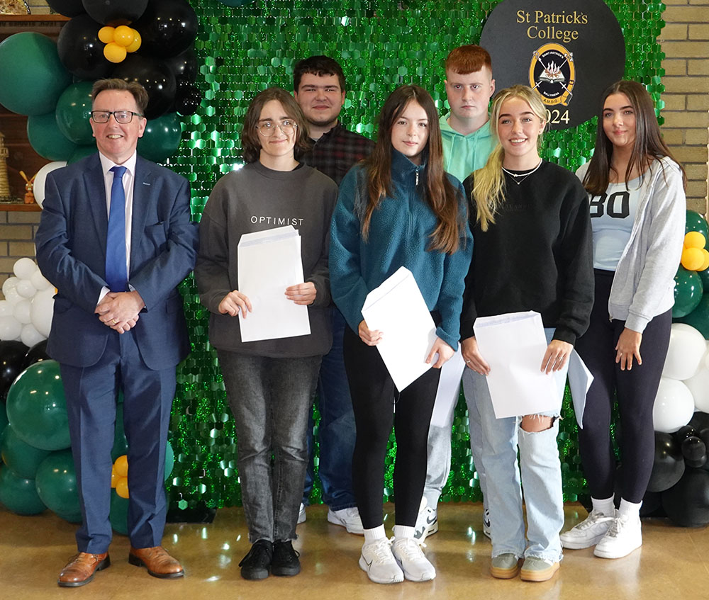

Mr Fitzpatrick with some of the twelve students who have achieved at least nine GCSE grades at A*-C

Mr Fitzpatrick and the staff of St Patrick’s also wish all of the school’s Year 12 students every success in the next stage of their education and look forward to welcoming most of them back to begin Sixth Form studies in St Patrick’s, where they will continue to achieve great success.

