Excellent results for St Patrick’s College, Ballymena
A Level students
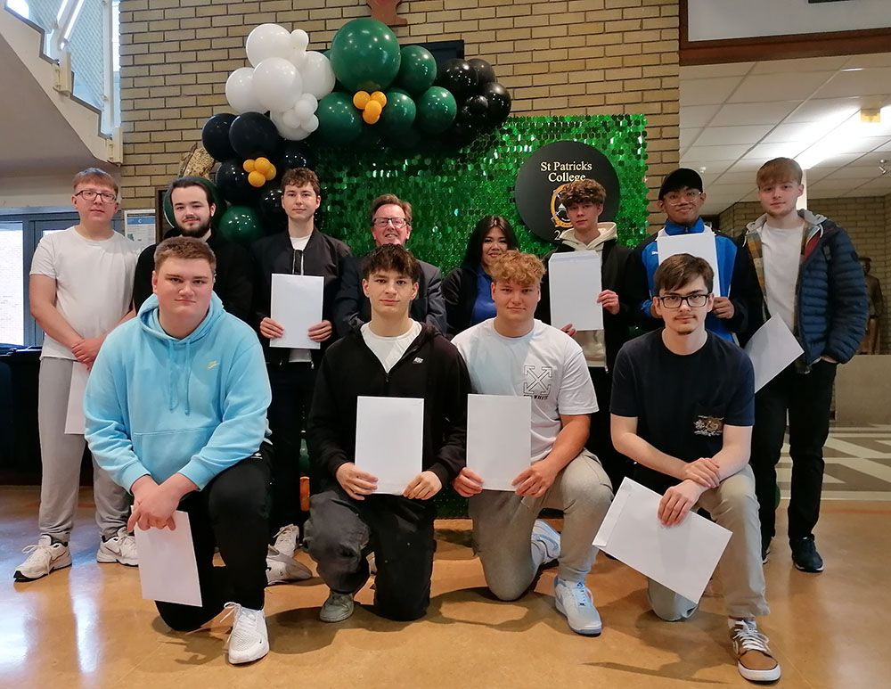
A2 students celebrating their results at St Patrick’s College, Ballymena

St Patrick’s College, Ballymena’s Principal Paul Fitzpatrick this week congratulated his students on the outstanding success they have achieved in their recent GCE results, reflecting the strong commitment of pupils, parents and staff to ensuring that all pupils reach their full potential.

Overall, St Patrick’s College Sixth Form students have seen great success this year. In total, 33 A or A* grades have been achieved by the College’s Year 14 students, accounting for 38% of the total grades obtained by the Year Group, significantly in excess of the UK average for A* and A grades this year. Top results in the school include one student who has two A* grades and an A. Another student has achieved three A grades, and a third – who took four A Levels –has obtained two A* grades and two B grades. A further seven St Patrick’s students have achieved at least two A grades and a B grade in their A2 examinations.
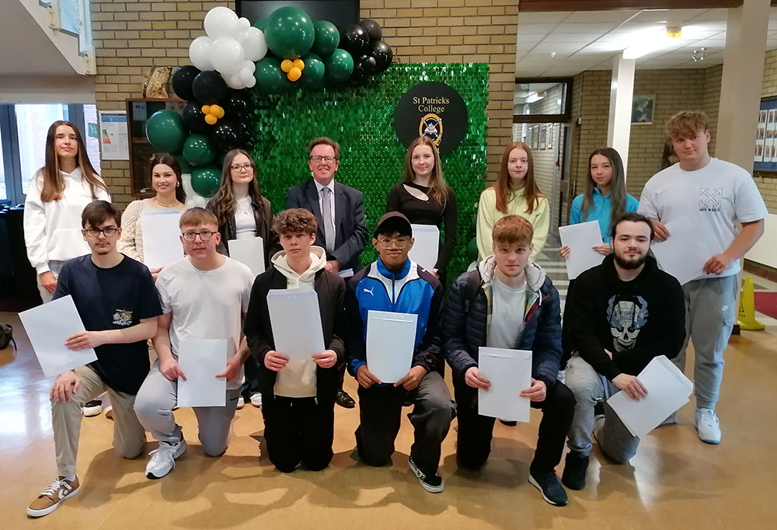
Some of the students who have achieved three grades at A* to C in St Patrick’s College, Ballymena

A Level results are excellent across the Year Group, with 56% of the College’s Year 14 students celebrating at least one A grade in their ‘A’ Level results this week, and 26% also celebrating at least one A* grade.

Further success has been achieved at AS Level, where St Patrick’s students have completed a highly successful first year of their ‘A’ Level courses, which will help them achieve further success in their A2 results next Summer.
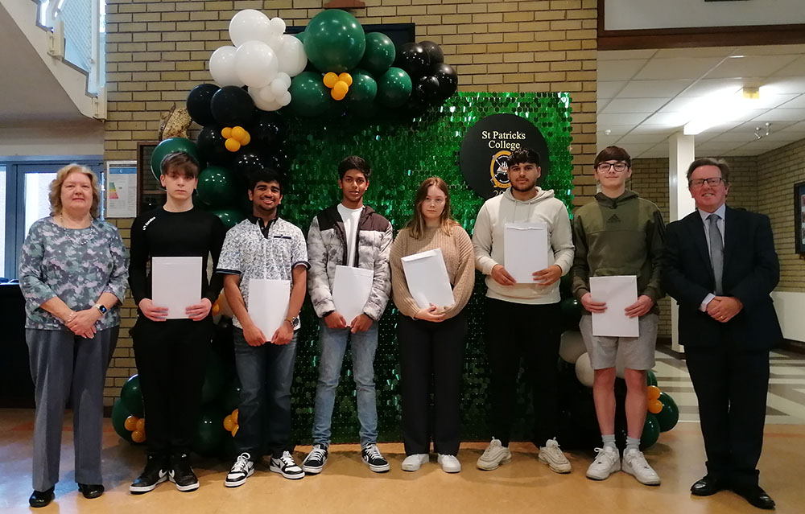
AS students celebrating their results with Mrs Harkins (Assistant Principal) and Mr Fitzpatrick (Principal)

St Patrick’s College Principal, Paul Fitzpatrick, congratulated all of his ‘A’ Level students on their outstanding level of achievement.

‘I am delighted to see so many of our students achieving at this top level and it is testament to the effort that they and their teachers have put into their ‘A’ Level work over the past two years. The last five years have been an extremely unsettling period for young people, but our students’ excellent results are testament to the strong work they have put into their courses.

‘Almost half of our students have achieved at least two A grades out of their ‘A’ Levels, and I am delighted with our students’ overall high level of achievement. A particular word of congratulation must go to our Double Award Art students, and to our Construction and Polish Departments, which all saw 100% of their students achieve grades at A*-C. A very high percentage of our Art, Construction and ICT students achieved Distinction or Starred Distinction (A*) grades. 84% of Art grades were at Starred Distinction level, while half of our Construction students and 57% of our ICT students achieved at least a Distinction grade.
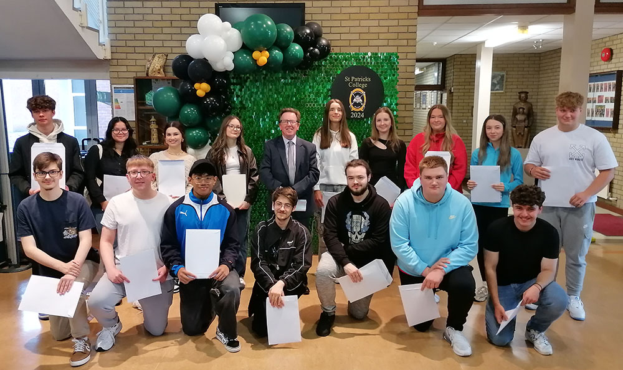
Celebrating students who have achieved at least two A grades in their results

‘We are very pleased that such a significant number of our students have achieved three of their ‘A’ Levels at A*-C, and I am delighted to say that our students have achieved excellent results in both their AS and A2 courses.

‘We have many Sixth Form students who come to us from other schools when they have completed their GCSE courses, and their success at ‘A’ Level shows how well they settle into life here at St Patrick’s College. It is notable that some of these students are among our very highest achievers.’

Some of our students also completed courses in collaboration with other local schools or the Northern Regional College, and Mr Fitzpatrick passed on his congratulations and thanks to those institutions for all they have done to help our students to achieve their full potential.
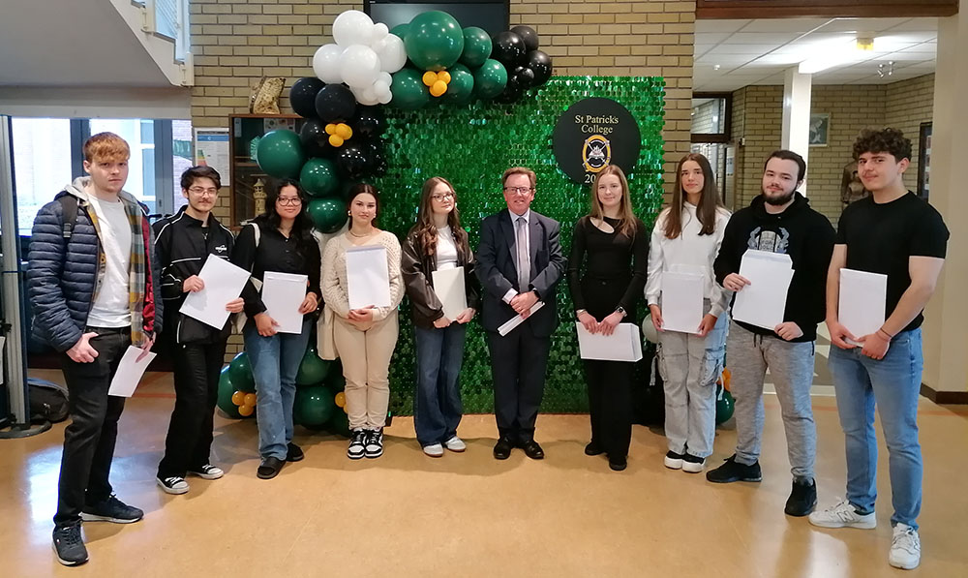
St Patrick’s College students who have all achieved at least one A* grade in their A Levels

Mr Fitzpatrick congratulated and thanked the school’s staff for the support, guidance and advice they have given the school’s young people during their ‘A’ Level studies. He further congratulated the students’ parents, who have provided unfailing support to their children during this very busy two year period.

‘The high level of success achieved by our Year 13 students in the first year of their ‘A’ Level programmes gives them every encouragement to go on and achieve further success next year in their A2 year.’

Onward destinations for this year’s A2 students include:
- Ulster University for degrees in Art & Design, Biomedical Engineering, Computer Science, English with Education, Psychology and Software Engineering
- Stranmillis College, Belfast for Early Childhood Studies
- Liverpool John Moores University for Architecture and Interior Architecture
- Edge Hill University Liverpool for Business Management
- Kingston University London for Architecture
- Manchester University for International Business Management
- Manchester Metropolitan University for Education
- Nottingham Trent University for Computer Science
- Anglia Ruskin University for Social Work

Mr Fitzpatrick wished the Sixth Form students who will be leaving the College this year every success in the future as they move on to Further and Higher Education and into the world of work. He thanked them for the outstanding contribution they have made to the school, and also for the example they have given younger pupils at St Patrick’s College, through their excellent academic performance, their work as Pupil Mentors to the younger pupils and the many other ways in which they have taken part in the life of the school. Undoubtedly they have followed the school’s Mission Statement of living and practising their faith and their commitment to one another. He said, ‘They have been outstanding role models to the other pupils and exemplary young people, and we at St Patrick’s College wish all of them every success in the future. They will very much continue to be a part of our school community as they move forward to an exciting new chapter in their lives.’

